Final Year Project (2024-2025)
Gamified Learning: Learn With Engagement
Jayaram A , Priyadarshini V, Yuthikshaa M, Yuvaraj T
Guide: Dr.Bama Srinivasan

AIM:
This project focuses on developing an innovative and adaptive learning platform that uses gamification to make education more engaging for students. By incorporating storytelling and interactive assessments into a game-based structure, it aims to personalize learning experiences and foster deeper understanding. The platform adjusts to each student’s performance, allowing them to learn at their own pace while reinforcing key concepts. Ultimately, the goal is to create a dynamic and enjoyable learning environment that provides real-time feedback, adaptive difficulty, and continuous improvement.

INTRODUCTION:
Our gamified learning project blends storytelling-based education with interactive game mechanics to create an engaging learning experience for students. So far, we have completed 30-40% of the project, focusing on key features that integrate learning and evaluation. The learning part is centered around a Snake game, where students progress by answering questions. This approach is designed to make learning interactive and adaptive to each student’s pace. We used advanced techniques like multi-linear models and regression to predict the difficulty level of students, ensuring a personalized learning path. The adaptive model ensures students can progress through the game based on their individual needs.

LITERATURE SURVEY:
[1] Fiona Fui-Hoon Nah, Qing Zeng, Venkata Rajasekhar Telaprolu, Abhishek Padmanabhuni Ayyappa & Brenda Eschenbrenner (2014). Gamification of Education: A Review of Literature. International Conference on HCL in Business.

The literature on the gamification of education, focusing on its impact on student engagement, motivation, and learning outcomes. It explores various gamification strategies and their effectiveness in educational settings. The review also identifies challenges and potential areas for future research in the application of gamification in education.

[2] Ahmed Tlili, Mouna Denden, Fathi Essalmi, Mohamed Jemni, Ronghuai Huang, Ting-Wen Chang (2019). Personality Effects on Students' Intrinsic Motivation in a Gamified Learning Environment. International Conference on Advanced Learning Technologies (ICALT).

Examines how personality traits influence students' intrinsic motivation within a gamified learning environment. It explores the relationship between different personality types and their engagement and success in gamified educational settings. The study provides insights into how personalized gamification strategies can be designed to cater to individual student needs and preferences.

[3] Pallavi Asthana, Sumita Mishra, Nishu Gupta, Mohammad Derawi, Anil Kumar (2023). Prediction of Student’s Performance With Learning Coefficients Using Regression Based Machine Learning Models. IEEE Access

Explores the prediction of student performance using regression-based machine learning models. It focuses on incorporating learning coefficients to enhance the accuracy of performance predictions. The study demonstrates how these models can be utilized to identify key factors influencing student outcomes and improve educational strategies.

[4] S. S. Manathunga, Y. A. Illangasekara (2023). Retrieval Augmented Generation and Representative Vector Summarization for large unstructured textual data in Medical Education arXiv preprint arXiv:2308.00479 (2023)

Discusses the application of Retrieval Augmented Generation (RAG) and Representative Vector Summarization techniques to manage and summarize large, unstructured textual data in medical education. It highlights how these advanced methods improve the efficiency and accuracy of information retrieval and summarization in complex educational materials. The study provides insights into enhancing medical education through innovative data processing approaches.
PROBLEM STATEMENT:
The core problem is to make learning engaging and adaptive, allowing students to learn at their own pace while maintaining educational rigor. We addressed this by synthesizing a dataset based on the learning difficulties of 5th-grade students. The evaluation dynamically adjusts itself based on the user's performance using a multi-linear model and regression techniques. Additionally, reinforcement learning is used to generate game configurations that keep the experience fun and challenging.

ARCHITECTURE DIAGRAM:

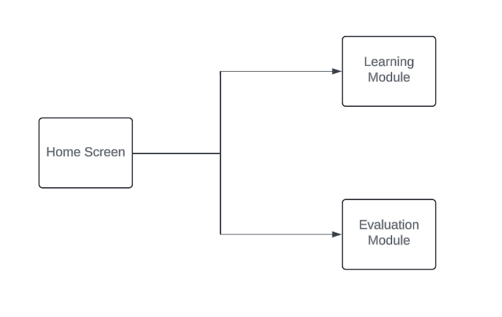
Overall architecture
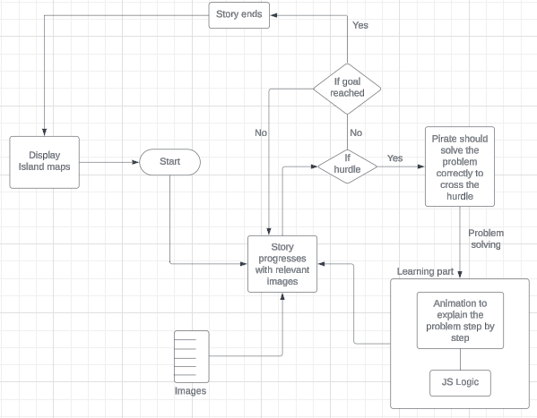
Learning module with Pirate story

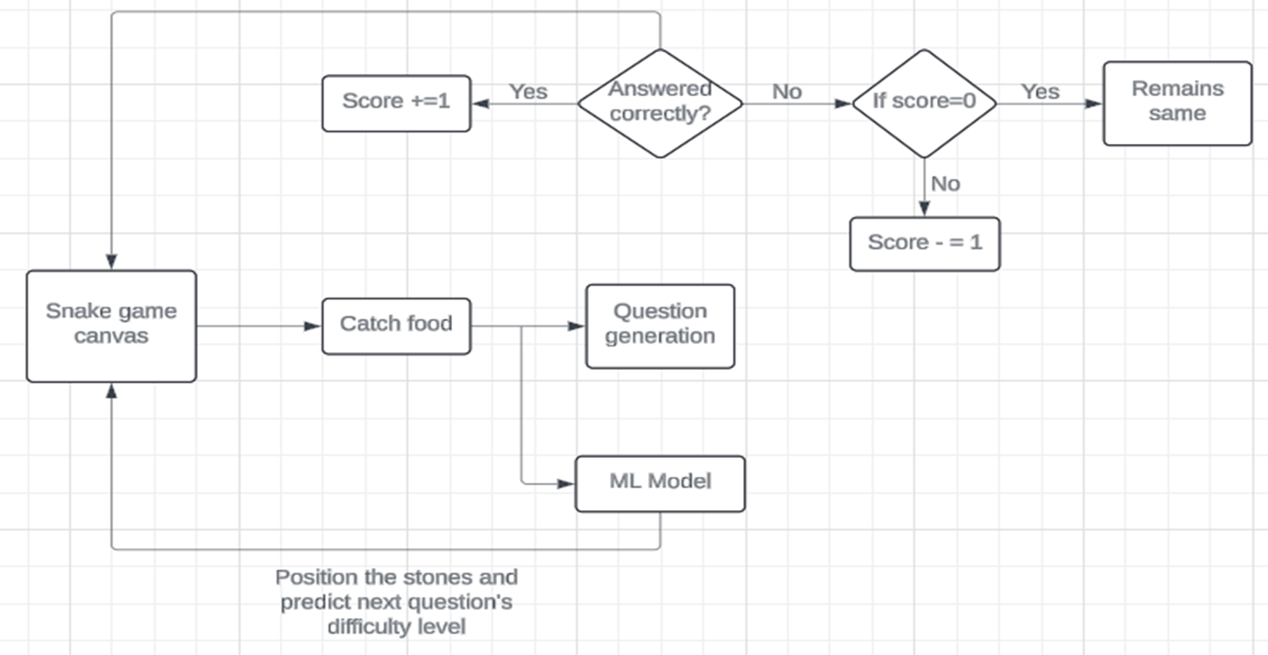
Evaluation module using Game

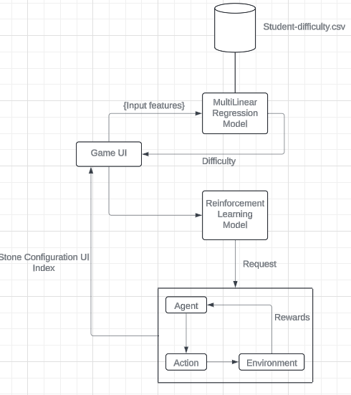
ML Model

PROPOSED SOLUTION:
To improve the accuracy of the predicted difficulty, we propose refining the multi-linear regression model through optimization techniques like gradient descent to minimize errors. Incorporating additional features such as response time, number of attempts, and student performance history will enhance the model's prediction capabilities. Regular evaluation using metrics like Mean Squared Error (MSE) and R² Score will ensure continuous improvement. Furthermore, reinforcement learning will dynamically adjust game configurations based on performance, providing appropriate challenges. This approach will create a personalized, adaptive learning experience, enhancing student engagement and progress.

CONCLUSION:
Our gamified learning platform leverages advanced machine learning models to create a personalized and adaptive educational experience. By integrating multi-linear regression and reinforcement learning, we predict student difficulty levels and adjust both the learning content and game
environment dynamically. The use of metrics like Mean Squared Error and R² Score ensures continuous refinement of our prediction models, while real-time feedback from the dataset helps enhance engagement and pacing. This innovative approach not only makes learning more engaging but also empowers students to progress at their own pace, ultimately fostering deeper understanding and improved learning outcomes.

